Student name : Kobilov Ilkhomjon

Student ID : 201923250

**Q1) Select True or False for the followings:**

1. True
2. False
3. False
4. True
5. True
6. False
7. False
8. True
9. True

**Q2) Symbol Table**

1. Insert and search both perform equal in any case
2. A binary search tree with a 2–3 tree is fully balanced. Because each internal node has two or three offspring, it is known as a 2-3 tree. The data structure provides worst-case O(log n) time complexity for search and insert operations in a 2-3 tree since every path from root to leaf has the same length.

**Q3) Given the following BST**

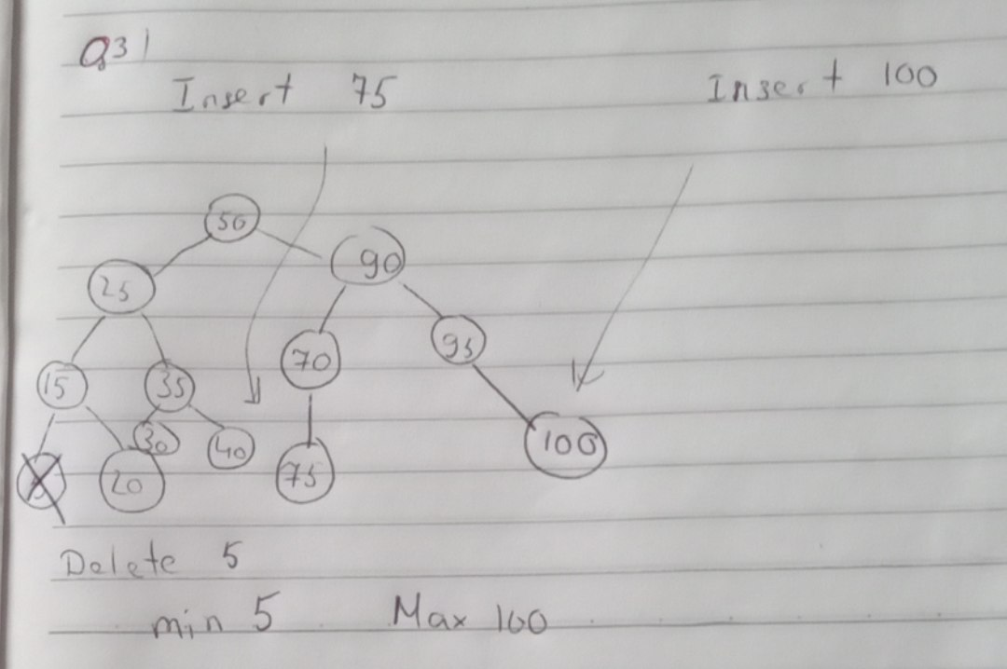

**Q4) Given the following LLRB tree**

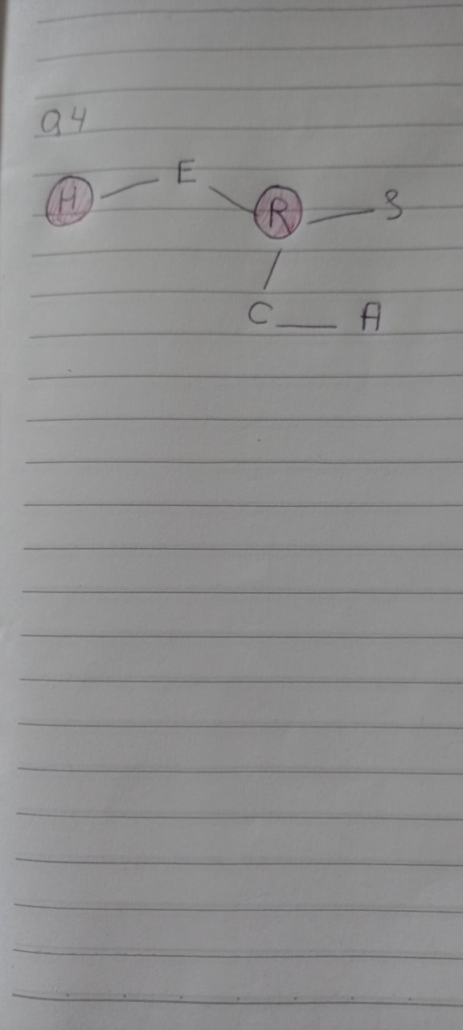

**Q5) Hash Tables**

1. A -Two key-value pairs that have equal keys but different values
2. A - insert key 35

**Q6) Graphs**

1. Adjacent matrix > Adjacent List > List of edges
2. The Array[] of Linked List Adjacency List is the same size as the number of Vertices in the graph. A Linked List exists for each Vertex. The reference to the other vertices that share an edge with the current vertex is represented by each Node in this Linked list. The weights can be kept in the Linked List Node as well.